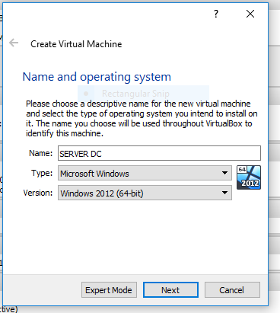
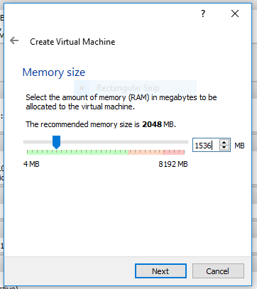
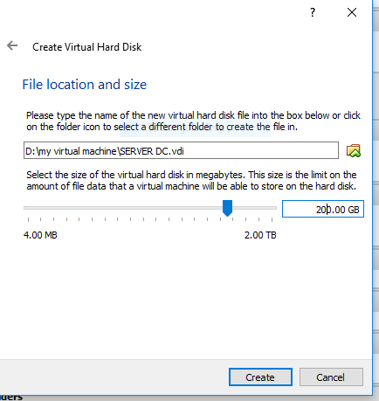
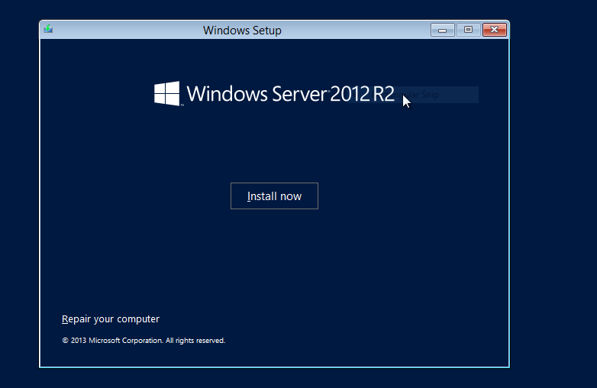
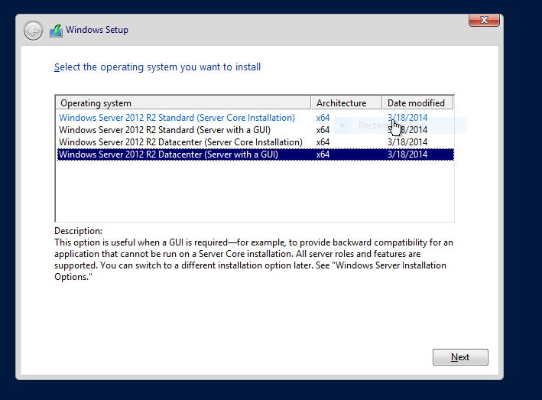
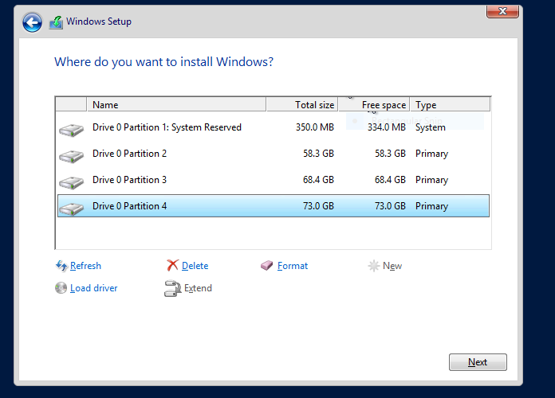
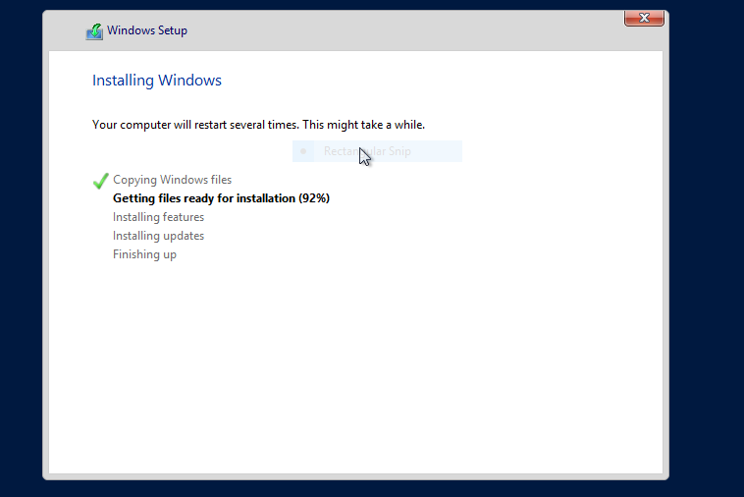
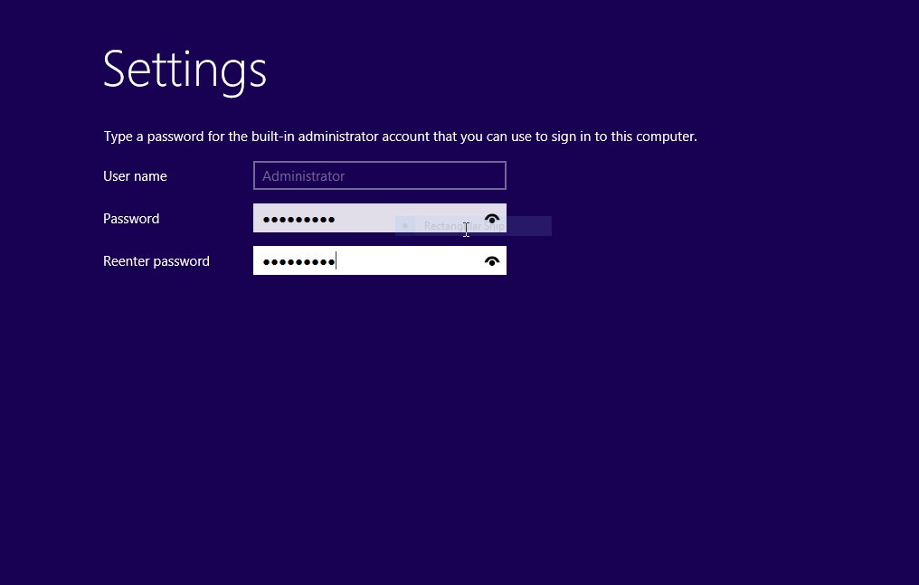
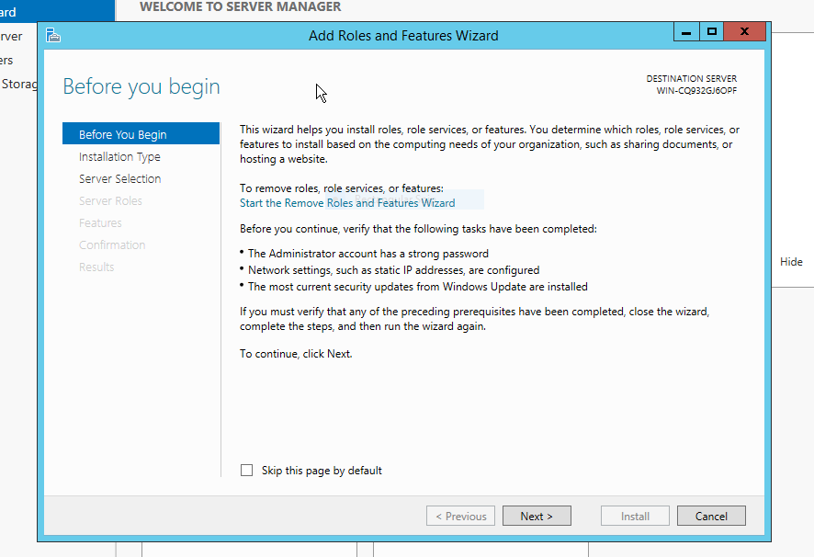
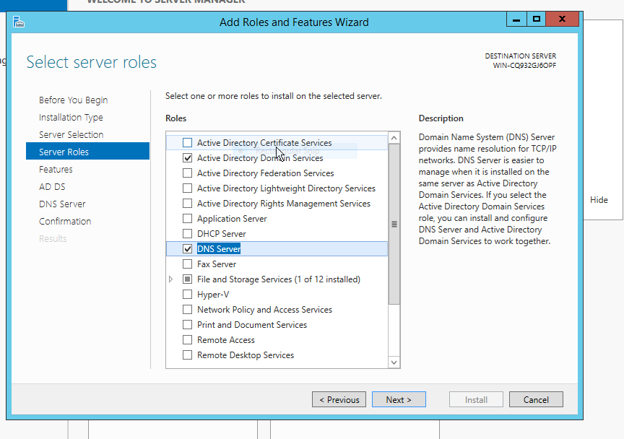
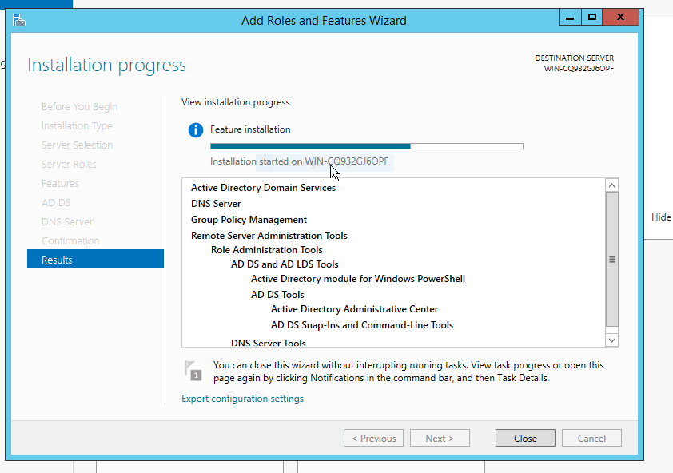
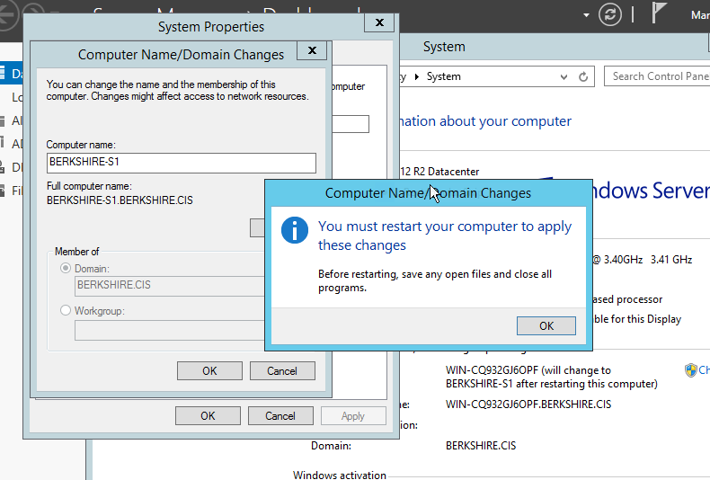
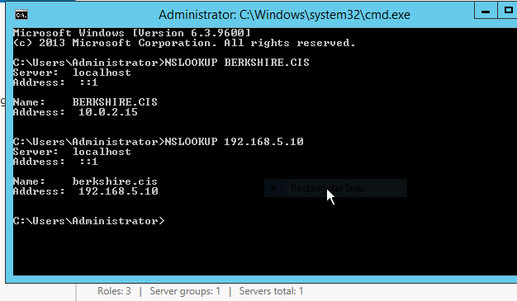
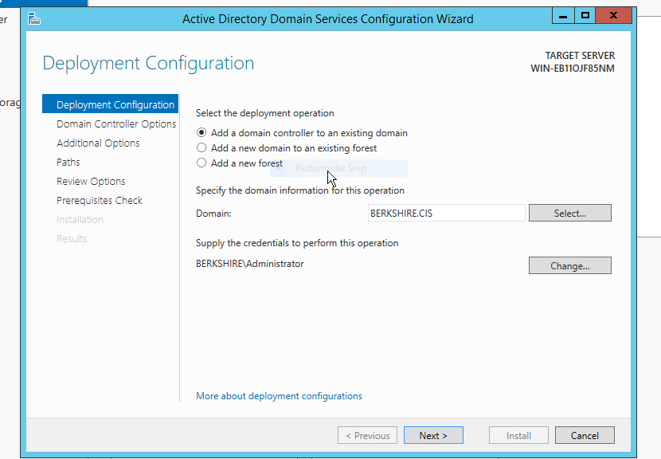
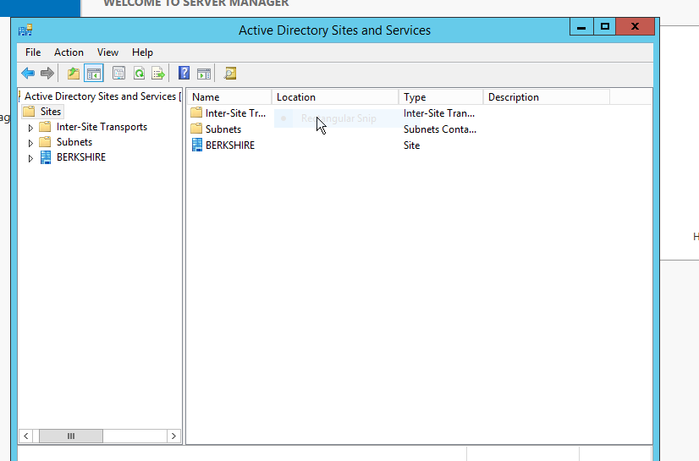
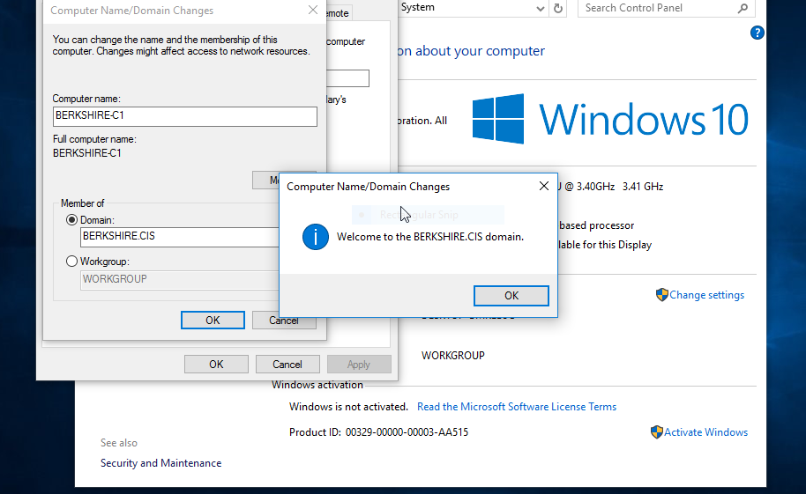
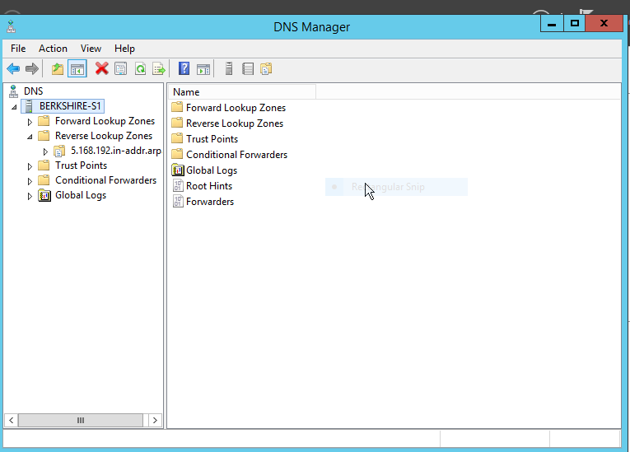
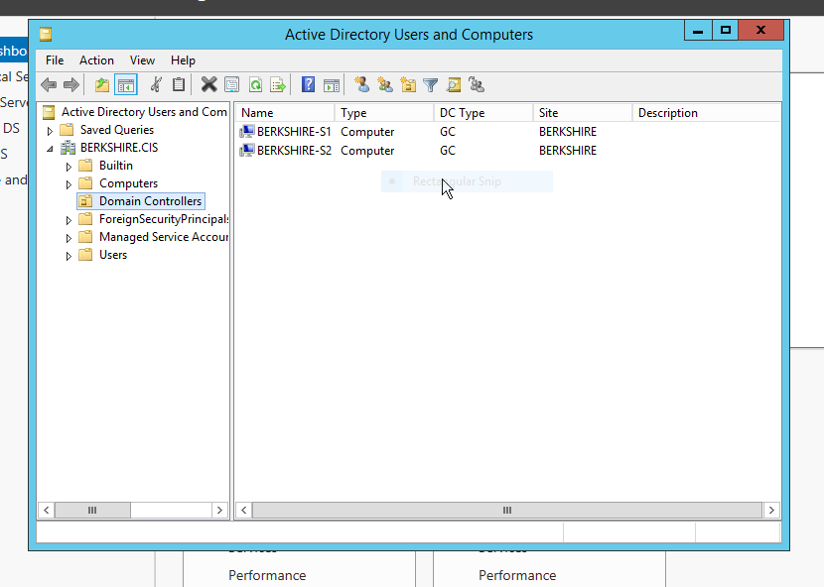
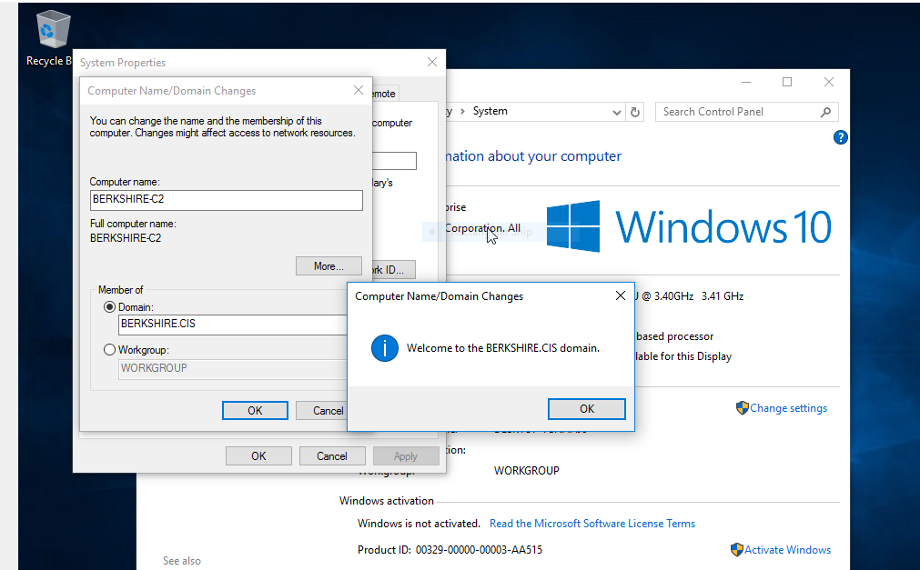
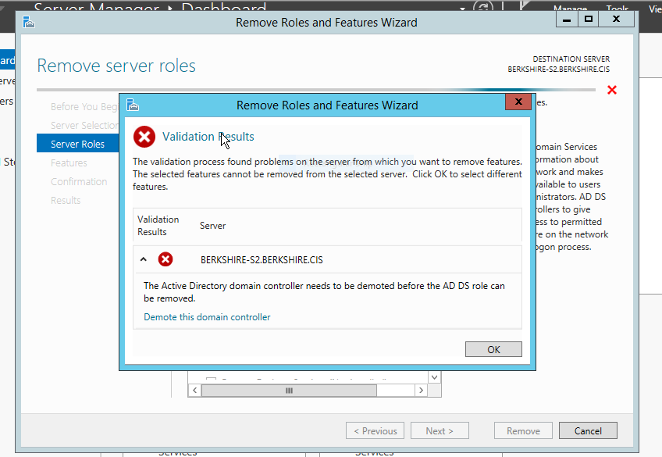
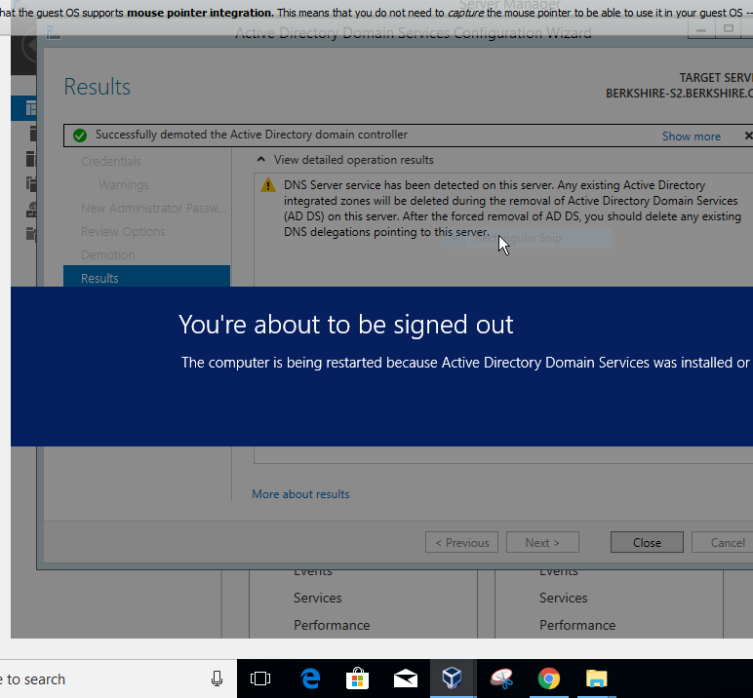
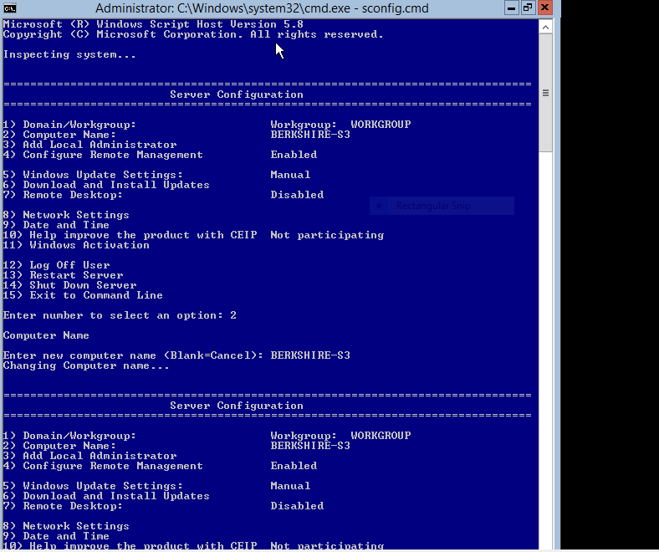
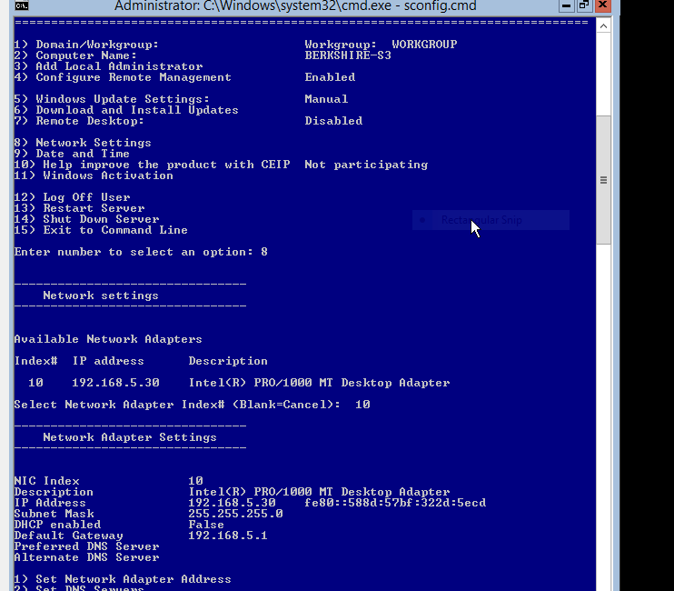
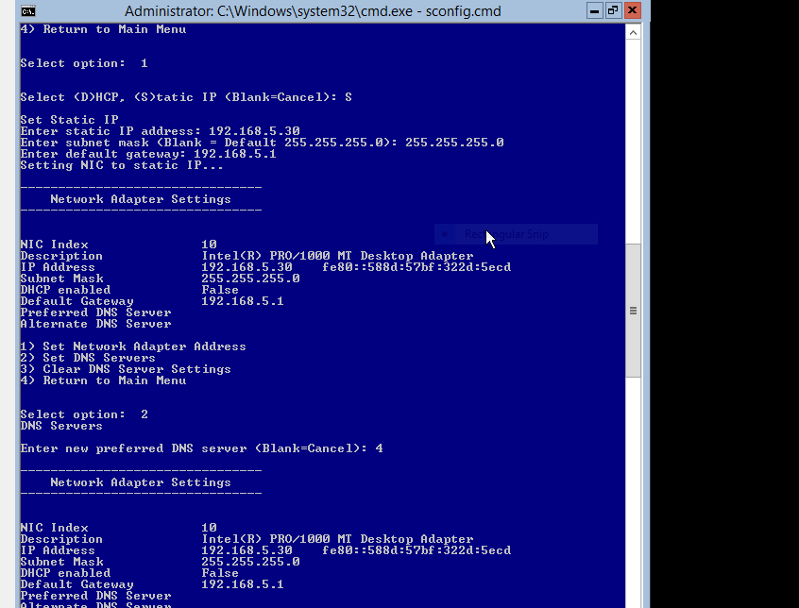
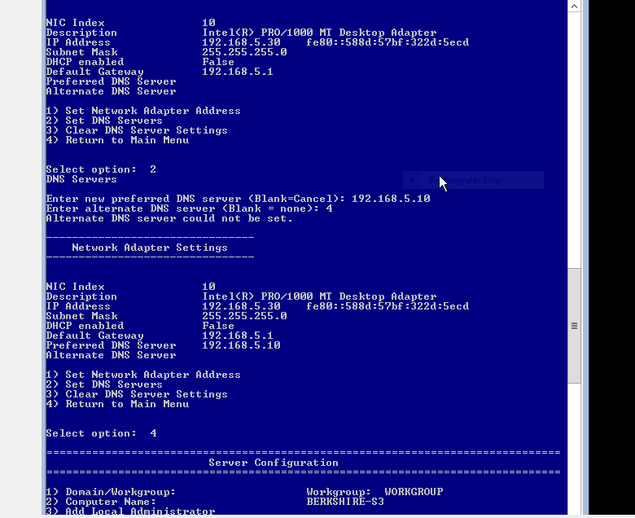
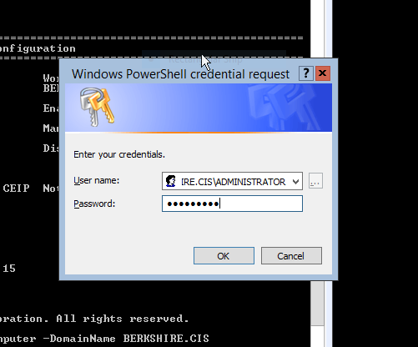
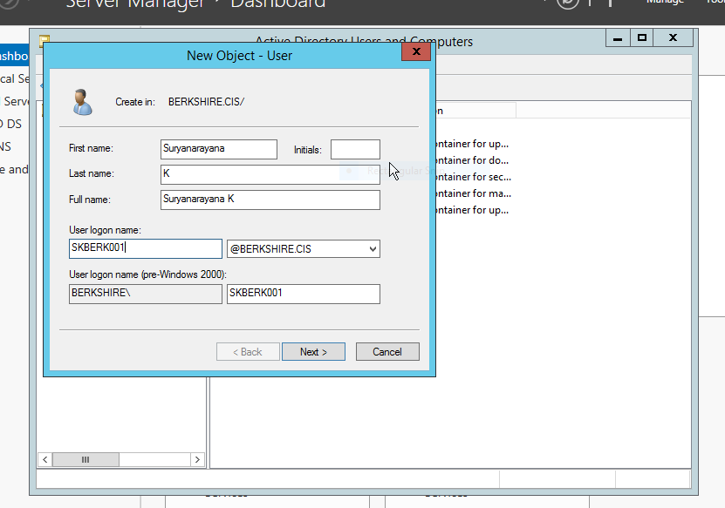
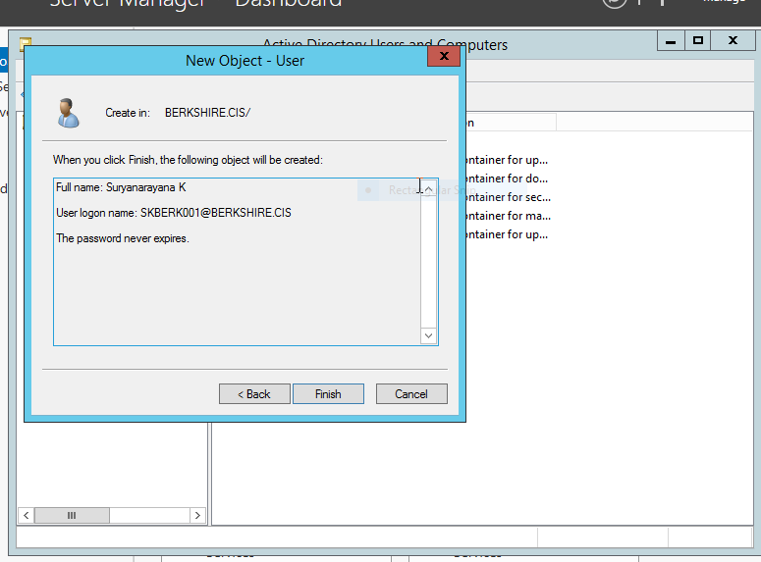
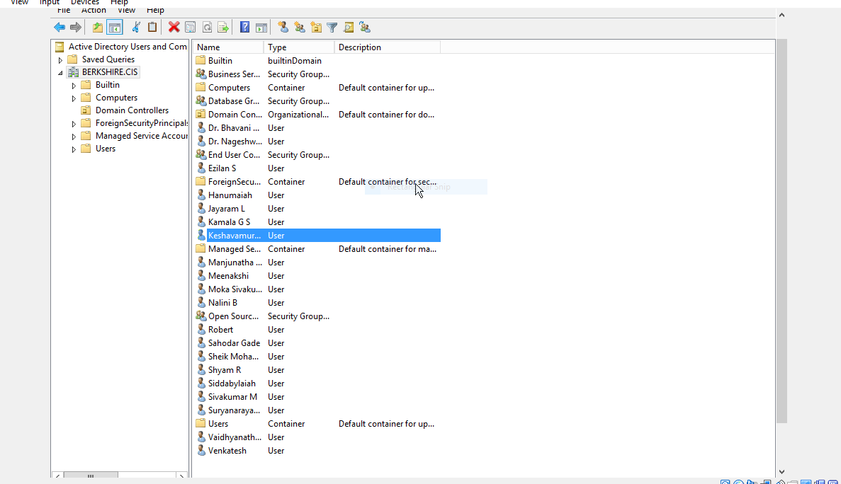
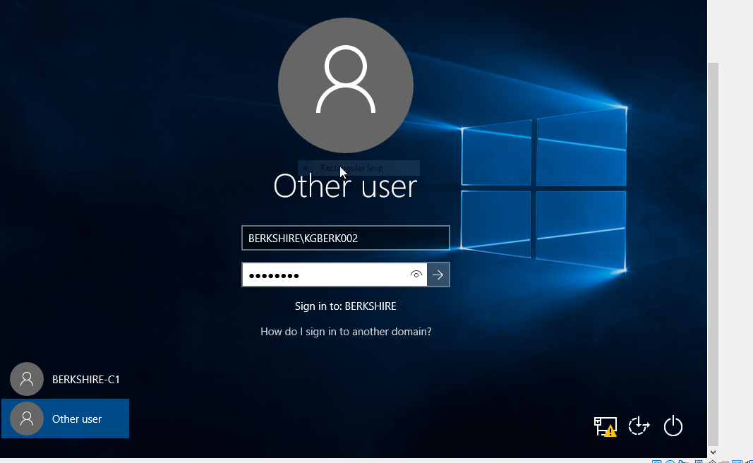
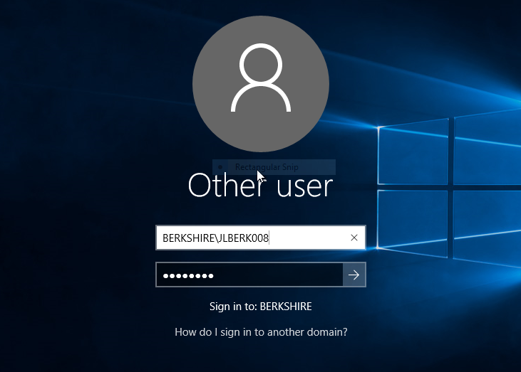
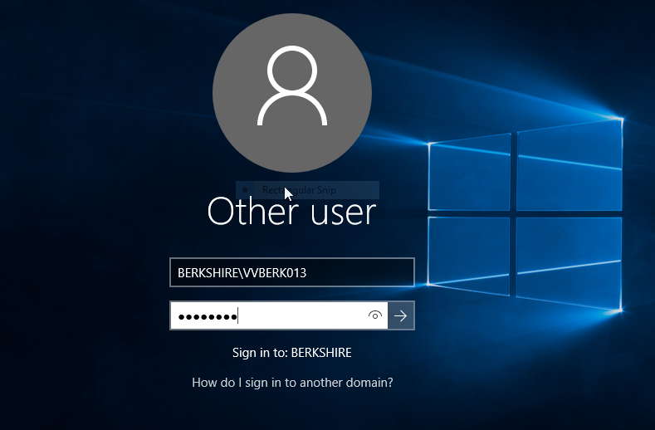
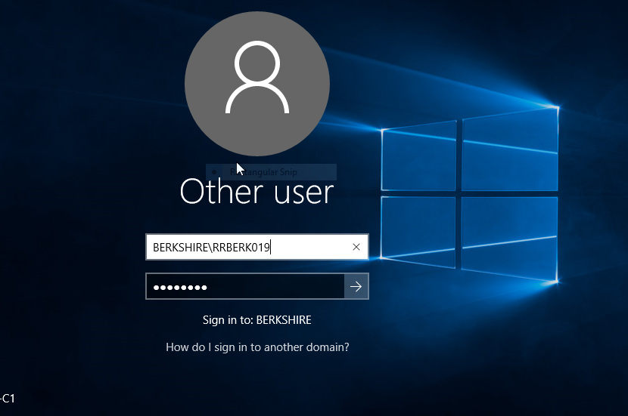
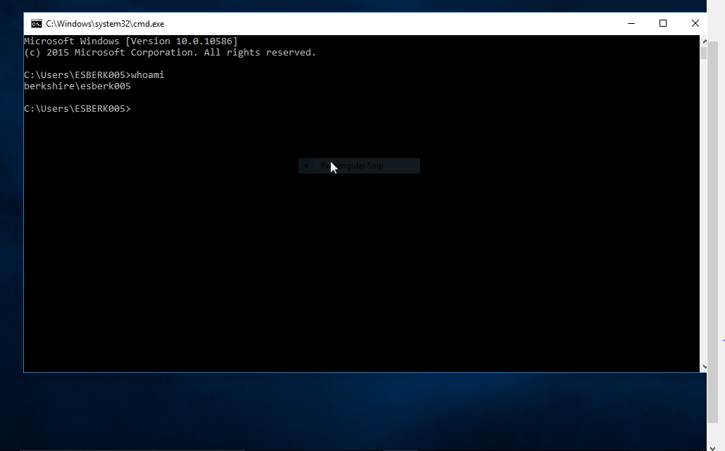
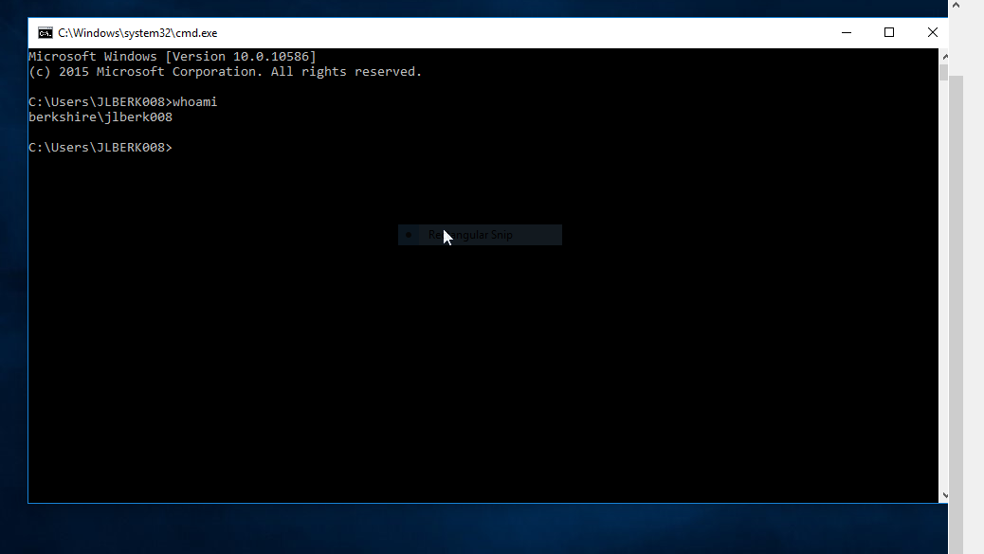
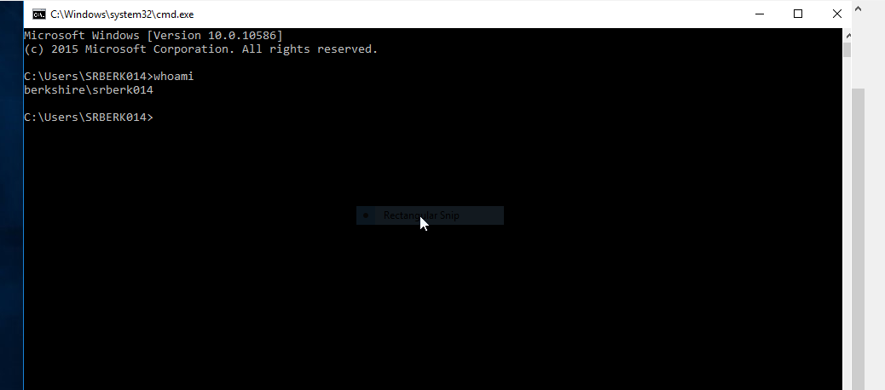
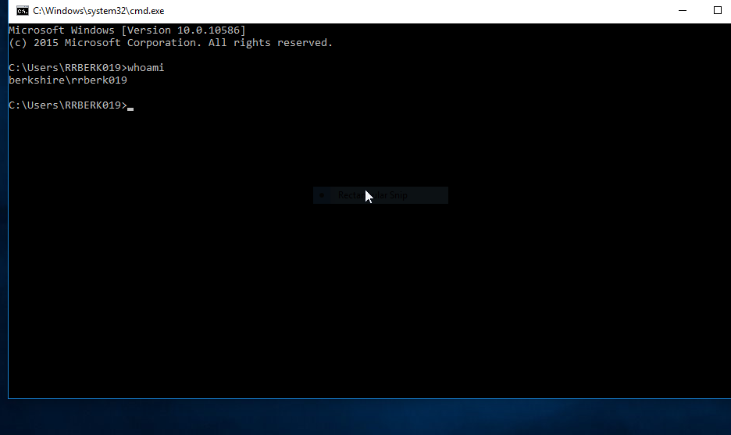
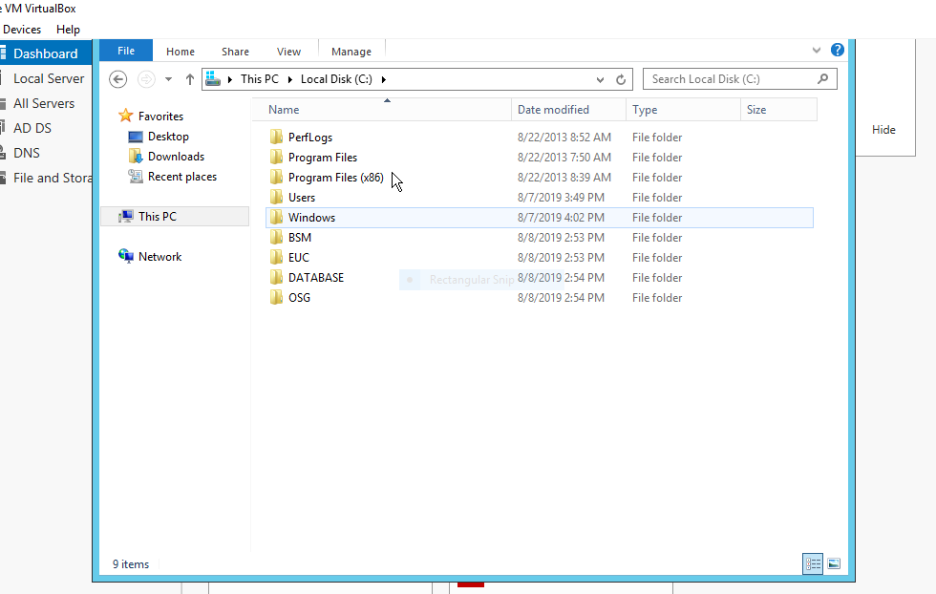
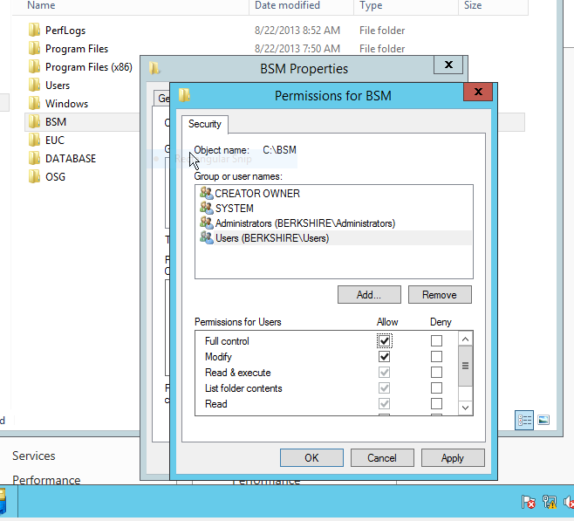
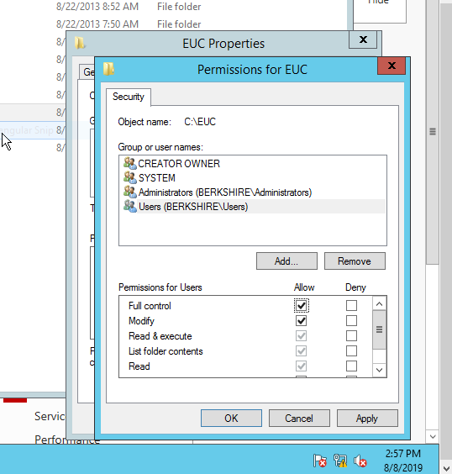
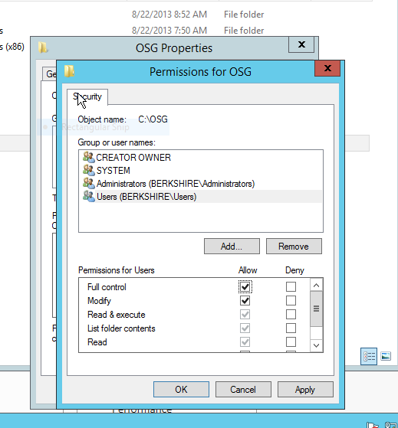
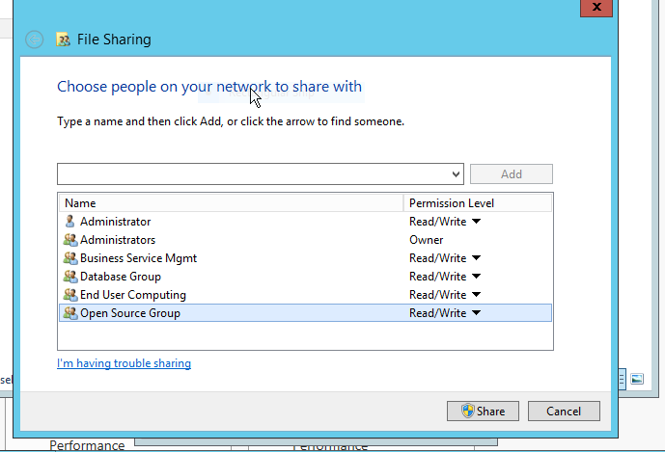
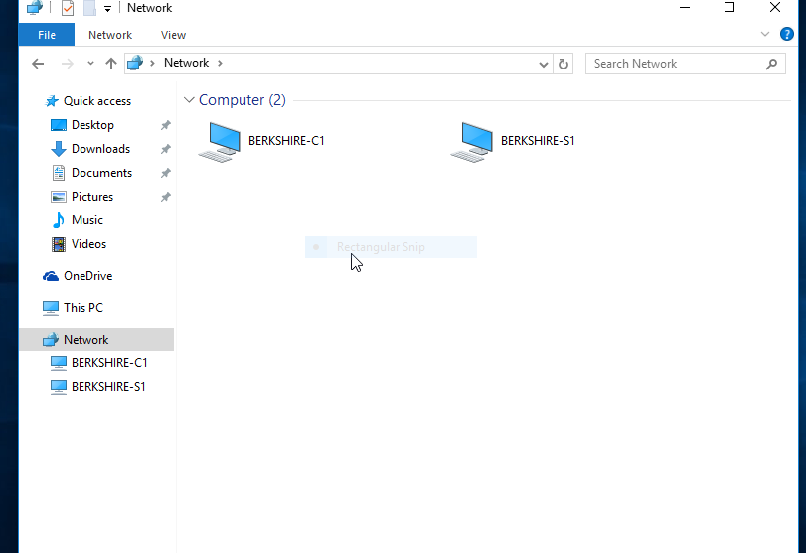
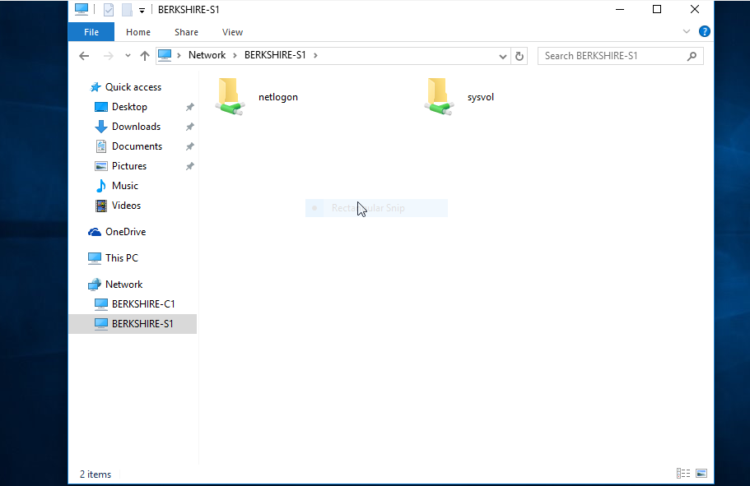
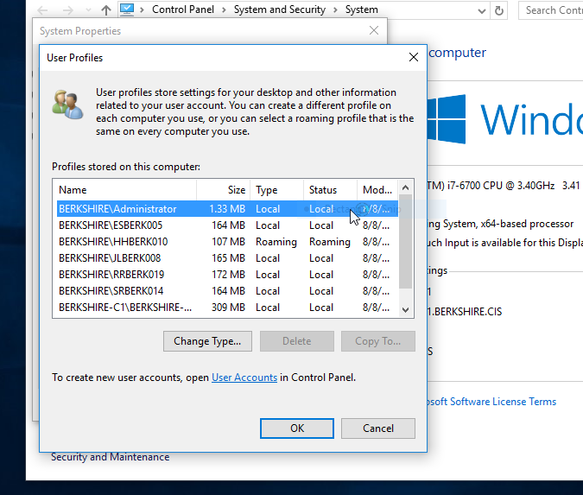
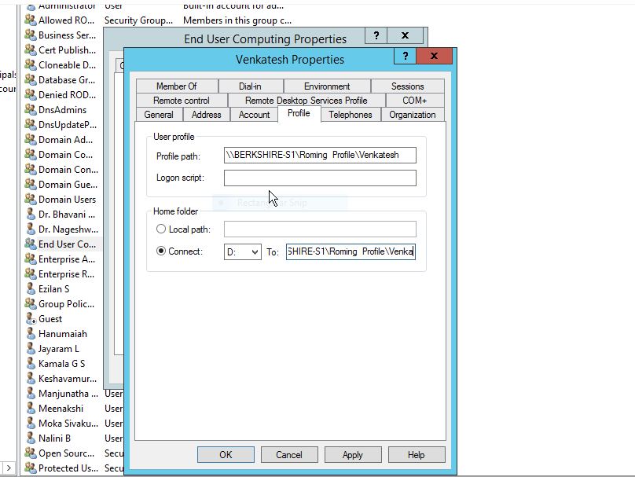
PRP TRAINING-WINTEL PROJECT
SERVER VIRTUALIZATION
CHETANYA ARORA
40036508

REQUIREMENT 1:
Entire Infrastructure needs to be built on Oracle Virtual Box 5.2.8 or above. In case the specified version is having some issues one can build the same in one version lower.

REQUIREMENT 2:
The POC (proof of concepts), should be built on Windows Server 2012 R2 and Windows 10. You are supposed to collect information and document the same that describes the Hardware/Software requirements for Windows Server 2012.

HARDWARE/SOFTWARE REQUIREMENTS:
PROCESSOR SUPPORT - 64 Bit*64 CPU
SPEED - 1.4 GHz
RAM/MEMEORY REQUIREMENT - 512 MB
SSD or HD SPACE - 32 GB+
OPTICAL DRIVE - DVD ROM DRIVE
DISPLAY - XGA (1024*768) monitor

REQUIREMENT 3:
Company should have a Domain name which should be a new forest created in Windows Server 2012 R2 with Datacenter Edition. Name of the domain will be Berkshire.CIS
Tasks
a) Create a virtual machine with the following configuration (2 GB RAM, 1 NIC, 1 CPU and 500 GB HDD).
b) Operating system should be Windows 2012 R2 Datacenter Server.
c) Hostname of the virtual machine needs to be BERKSHIRE-S1
d) Promote this virtual machine to be domain controller and provide the domain name as per requirement.
e) Setup/Confirm Forward Lookup Zone in DNS
f) Setup/Confirm Reverse Lookup Zone in DNS

REQUIREMENT 4
Customer wants the backup of the domain controller to be created so that there is a backup for S1 virtual machine. This machine should be acting as additional domain controller.
Tasks
a) Create a virtual machine with the following configuration (2 GB RAM, 1 NIC, 1 CPU and 500 GB HDD). b) Operating system should be Windows 2012 Datacenter Server
c) Hostname of the virtual machine needs to be BERKSHIRE-S2
d) Promote this virtual machine to be domain controller and provide the domain name as per requirement.
e) Setup/Confirm Forward Lookup Zone in DNS f) Setup/Confirm Reverse Lookup Zone in DNS

SAME WORKING AS REQUIREMENT 3

REQUIREMENT 5

Customer wants the Site Name of the domain controller to be changed to BERKSHIRE, which will represent the physical location of the Domain controller being installed.
Tasks
a) Change the SITE name of the of the Domain to BERKSHIRE. Change the Default-First-SiteName.
b) This can be done from Active Directory Site and Services.
c) Verify that the domain controllers are listed under servers.

REQUIREMENT 6
Customer wanted to check all the activities in the domain on a client operating system. As most of the Desktop Operating system is Windows 10, he also wanted the same to be implemented.
Tasks
a) Create TWO virtual machine with the following configuration (2 GB RAM, 1 NIC, 1 CPU and 500 GB HDD).
b) Hostname of the virtual machine needs to be BERKSHIRE-C1 and BERKSHIRE-C2
c) Both the systems created needs to be joined to the BERKSHIRE.CIS domain.
d) Verify the same by logging into Domain Controller and opening the Active Directory Users and Computers Tool.
e) In the computer container, both the virtual machines need to be listed there.

REQUIREMENT 7
After working with the current infrastructure customer feels that the load on the Desktop where Virtual machines are running is high and is not providing the required performance. Hence customer wants the additional domain controller to be removed i.e. de promoted.
Tasks
a) Login to BERKSHIRE-S2 machine with domain administrator and de-promote the machine as additional domain controller.
b) Verify the same in BRKSHIRE-S1 machine in Active Directory Users and Computers tool. The machine name should not be listed under domain controller. c) If the step a) is done properly then the server name can be deleted from Domain Controllers list.
d) Once the above tasks are done. Shut down BERKSHIRE-S2 machine.

REQUIREMENT 8
In order to increase the performance of having another server, customer wanted to check if the CORE version of Server can be implemented.
Tasks
a) Create a virtual machine with the following configuration (1 GB RAM, 1 NIC, 1 CPU and 500 GB HDD).
b) Operating system should be Windows Server 2012 R2, standard core Server.
c) Hostname of the virtual machine needs to be BERKSHIRE-S3.
d) This system needs to be joined to the BERKSHIRE.CIS domain.
e) Login to BERKSHIRE-S1 server and check in the Active Directory Users And Computers that this machine is listed.

REQUIREMENT 9
Customer wants to hire 20 employees and wants to create them in the Active Directory. Kindly create users in the Domain.
USER CREATION
20 USER CREATION
LOGIN PROCESS

REQUIREMENT 10
Customer wanted to verify that all users are able to login to the client machines when they join the organization.
Tasks
a) Login to BERKSHIRE-C1 with every employee’s that were created in the above requirement.
b) Once employee is able to login, open command prompt and type whoami command to verify the same that you have logged in as domain user.

REQUIREMENT 11

Customer wanted to secure every groups data in a separate folder that should be created in domain controller. Only employees belonging to the group should have access to the folder. You are requested to provide the same as per the tasks below.
Tasks
a) Login to BERKSHIRE-S1 as domain administrator and create following folders in C:\
a. BSM
b. EUC
c. DATABASE
d. OSG
b) Provide Full Control permissions to all members belonging to the respective domain.
c) Share all the above folders so that respective members can access the same from their client machines.
d) Login to BERKSHIRE-C1 machine with at least 1 member per group to verify that they have access to the network folder. Create a notepad file and save the same to that permissions can be verified.

REQUIREMENT 12
Seeing the nature of work for the End User Computing group where they save their data in their desktops, customer now wants their data to be available wherever they login. You are supposed to create roaming profile for all members of End User Computing group in domain
Tasks
a) Login to BERKSHIRE-S1 as domain administrator and for all members of group End User Computing, create roaming profile.
b) Verify the roaming profile in both the machines i.e. BERKSHIRE-C1 and BERKSHIRE-C2 machines.
c) Roaming profiles for all users of EUC group needs to be tested.

REQUIREMENT 13
Database Group members have asked the Management to allow them to login on all computers but their data not to be stored once they logout. Customer now wants to implement the same by using Mandatory Profile for all members of Database Group in domain
Tasks
a) Login to BERKSHIRE-S1 as domain administrator and for all members of Database group, create Mandatory profile.
b) Verify the Mandatory profile in both the machines i.e. BERKSHIRE-C1 and BERKSHIRE-C2 machines.
c) Mandatory profiles for all users of Database group needs to be tested.

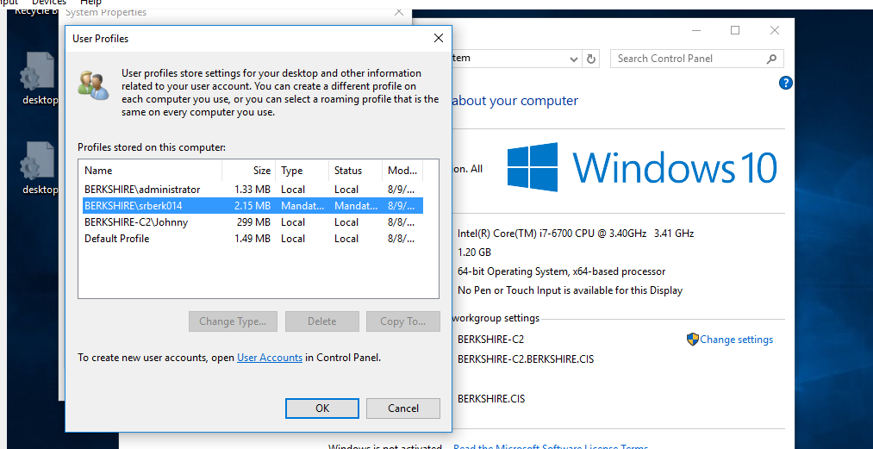
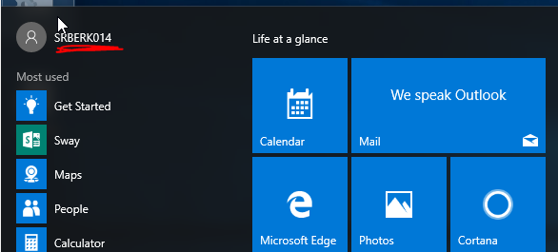
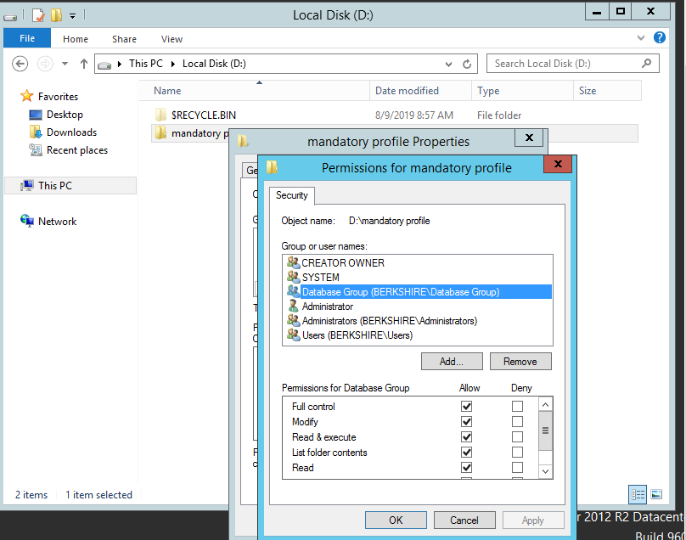

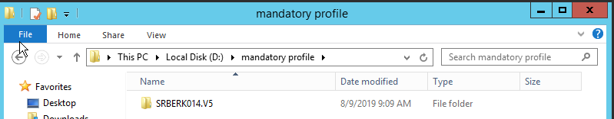


REQUIREMENT 14
.BusinessServiceMgmt
Computer Configuration\Administrative Templates\System\Network\Network Connections\
-Prohibit use of Internet Connection Sharing on your DNS domain network: ENABLED
-Prohibit use of Internet Connection Firewall on your DNS domain network: ENABLED
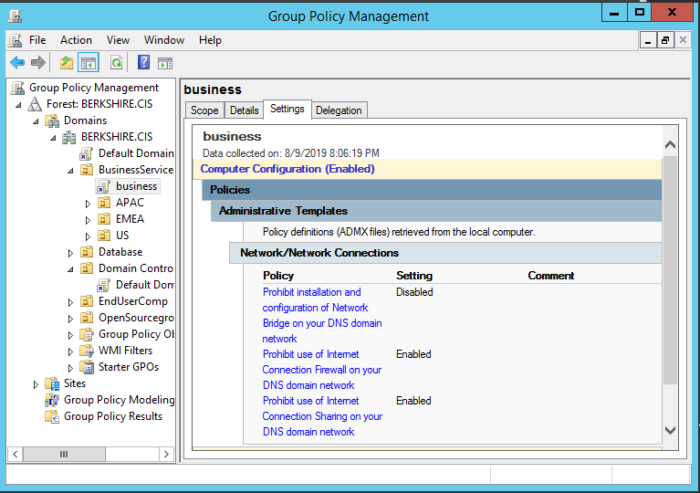
-Prohibit installation and configuration of Network Bridge on your DNS domain network: DISABLED.

b.EndUserComputingUser
Configuration\Administrative Templates\Windows Components\Internet Explorer\Internet Control Panel\
-Disable the General page: DISABLED
-Disable the Security page: ENABLED (U), DISABLED (ADA)
-Disable the Content page: ENABLED (U), DISABLED (ADA)
-Disable the Connections page: ENABLED (U), DISABLED (ADA)
-Disable the Programs page: ENABLED (U), DISABLED (ADA)
-Disable the Advanced page: ENABLED (U), DISABLED (ADA)
c.Database
User Configuration\Administrative Templates\Windows Components\Internet Explorer\Offline Pages\
-Disable adding channels: ENABLED (U), DISABLED (ADA)
-Disable adding schedules for offline pages: ENABLED (U), DISABLED (ADA)
-Disable all scheduled offline pages: ENABLED (U), DISABLED (ADA)
-Disable channel user interface completely: ENABLED (U), DISABLED (ADA)
-Disable downloading of site subscription content: ENABLED (U), DISABLED (ADA)
d.Open Source Group
Computer Configuration\Administrative Templates\System\Remote Assistance\
-Solicited Remote Assistance: DISABLED
-Offer Remote Assistance: ENABLED

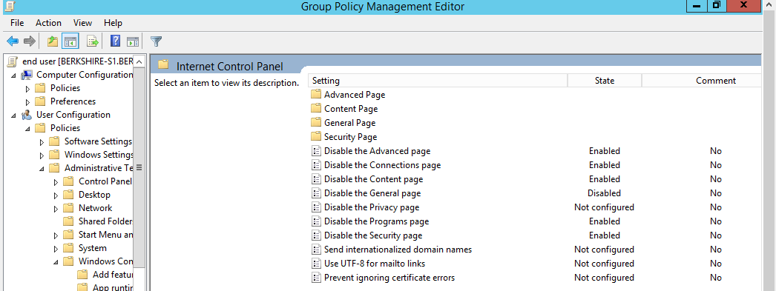

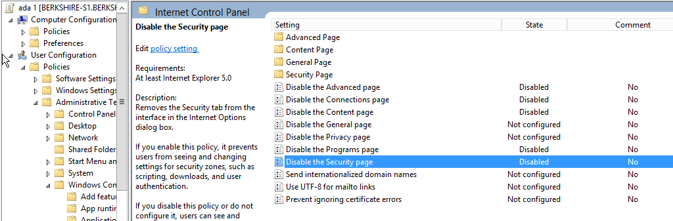
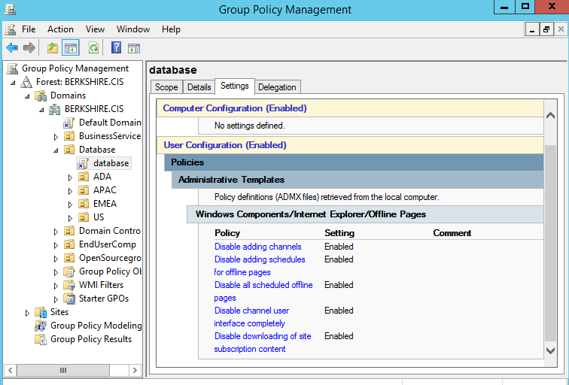

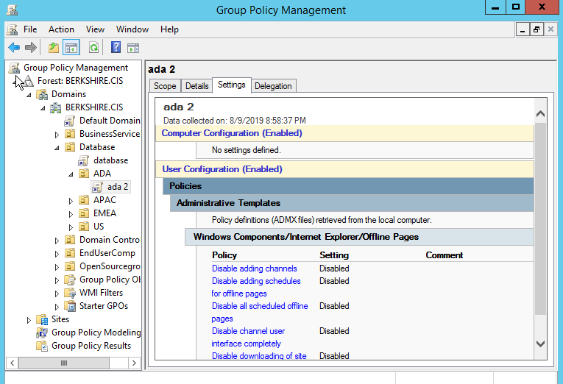

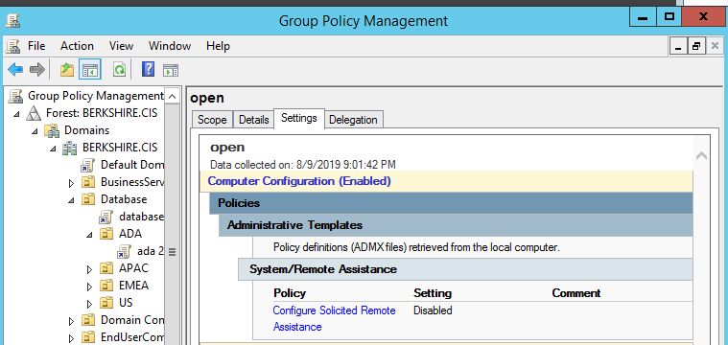

REQUIREMENT 15
Customer has decided to purchase 3 printers and wanted them to be installed on BERKSHIRE-S2 virtual machine and wants all the printers to be managed from 1 console. You are asked to implement the same
Tasks
a)Login to BERKSHIRE-S2 machine as domain administrator and install the following printers as Local Printers.
a. HP PhotoSmart Prem C410 Japan Class driver on LPT1 port.
b. KONICA MINOLTA PS Color Laser Class Driver on LPT2 port.
c. Xerox 770 Digital Color Press Class Driver on LPT3 port.
b)All printers should be available between 8:30 am to 6:00pm.
c)All groups should have only Printing permissions on all the printers.
d)KONICA printer should be shared and available to all groups.
e)Xerox printer should be shared and available ONLY to Database Group

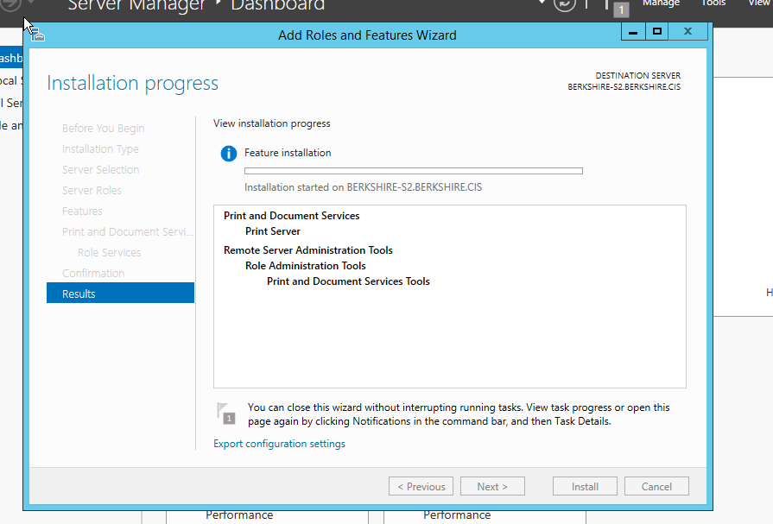
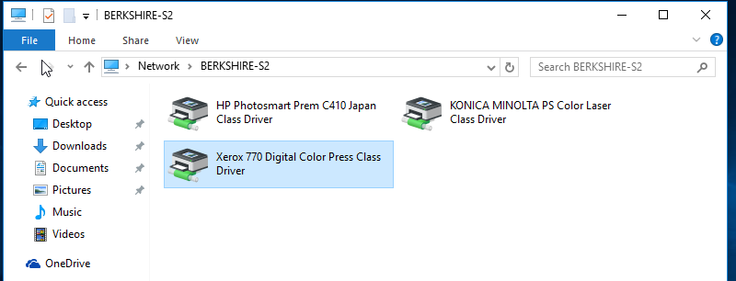
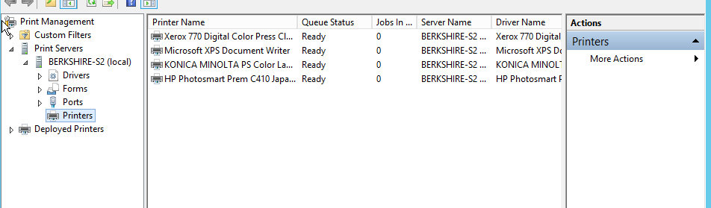

REQUIREMENT 16
Customer has plan to open up new venture in South Africa and for that wants to make sure that all the servers and client machines time should reflect the local time.
Tasks
a)Login to all virtual machines and change the time zoneof all systems to the following.
b)Login to all virtual machines (except domain controller) and SYNC the timeof virtual machine with the domain controller using NET command.
